

Course: Natural Language Processing
Teacher: Rafia Shaikh
Task: Project Report For Chatwell – Personal AI Therapist By
Faraz Hussain (FA22-BESE-0003) | Asad Raza (FA22-BESE-0054)
Taha Naveed (FA22-BESE-0007) | Kamran Ali (FA22-BESE-0029)

Table of Contents
1. Abstract 3
2. Core Features Of Chatwell 4
3. Introduction 5
3.1 Project Overview 5
3.2 Problem Statement 5
3.3 Solution 5
4. Methodology & Technology Stack 6
4.1 Development Methodology 6
4.2 Technology Stack 6
5. System Architecture 7
6. Implementation Details 8
6.1 Frontend (Glassmorphism UI) 8
6.2 Backend Logic (Flask) 8
6.3 Memory & Context 8
7. Key Features 9
8. Testing & Results 9
9. Conclusion & Future Scope 9
10. Project Demonstration Exhibits 10
10.1 Exhibit 01A 10
10.2 Exhibit 01B 10
10.3 Exhibit 01C 10
10.4 Exhibit 01D 11
10.5 Exhibit 01E 11
10.6 Exhibit 01F 11
10.6 Exhibit 02A 12
10.6 Exhibit 02B 12

- Abstract
The global mental health crisis has precipitated an urgent demand for accessible psychological support systems; however, traditional digital solutions often compromise user privacy by relying on cloud-based processing. The "ChatWell" project addresses this critical dichotomy by introducing a privacy-first, AI-powered mental health assistant that operates entirely within the user's local environment. By eliminating data transmission to external servers, ChatWell ensures absolute data sovereignty, fostering a secure space where users can discuss sensitive concerns without fear of surveillance or data breaches.
Technologically, the system represents a paradigm shift from resource-intensive Large Language Models (LLMs) to efficient Small Language Models (SLMs). It leverages Ollama to run Llama 3.2 (1B) locally on standard consumer hardware, ensuring low-latency performance without internet dependency. To mitigate the risk of AI hallucinations—a common flaw in generative models—ChatWell implements a robust Retrieval Augmented Generation (RAG) architecture. This pipeline retrieves context from a curated local ChromaDB vector database containing verified therapeutic interventions, such as Cognitive Behavioral Therapy (CBT) techniques, the "3-3-3 Rule" for anxiety, and "Box Breathing" for panic attacks, ensuring responses are clinically grounded rather than generic.
The application architecture is further fortified by a deterministic Safety Guardrail system that intercepts high-risk inputs using regex patterns to provide immediate crisis intervention resources. User continuity is maintained through a persistent memory system built on SQLite, allowing the AI to retain context regarding user demographics and conversation history across sessions. The user interface, developed with Flask and Tailwind CSS, features a modern "Glassmorphism" aesthetic designed to induce calmness. Ultimately, ChatWell demonstrates the viability of decentralized AI in healthcare, proving that effective, empathetic, and evidence-based mental health support can be delivered without compromising user privacy.

- Chatwell’s Core Features
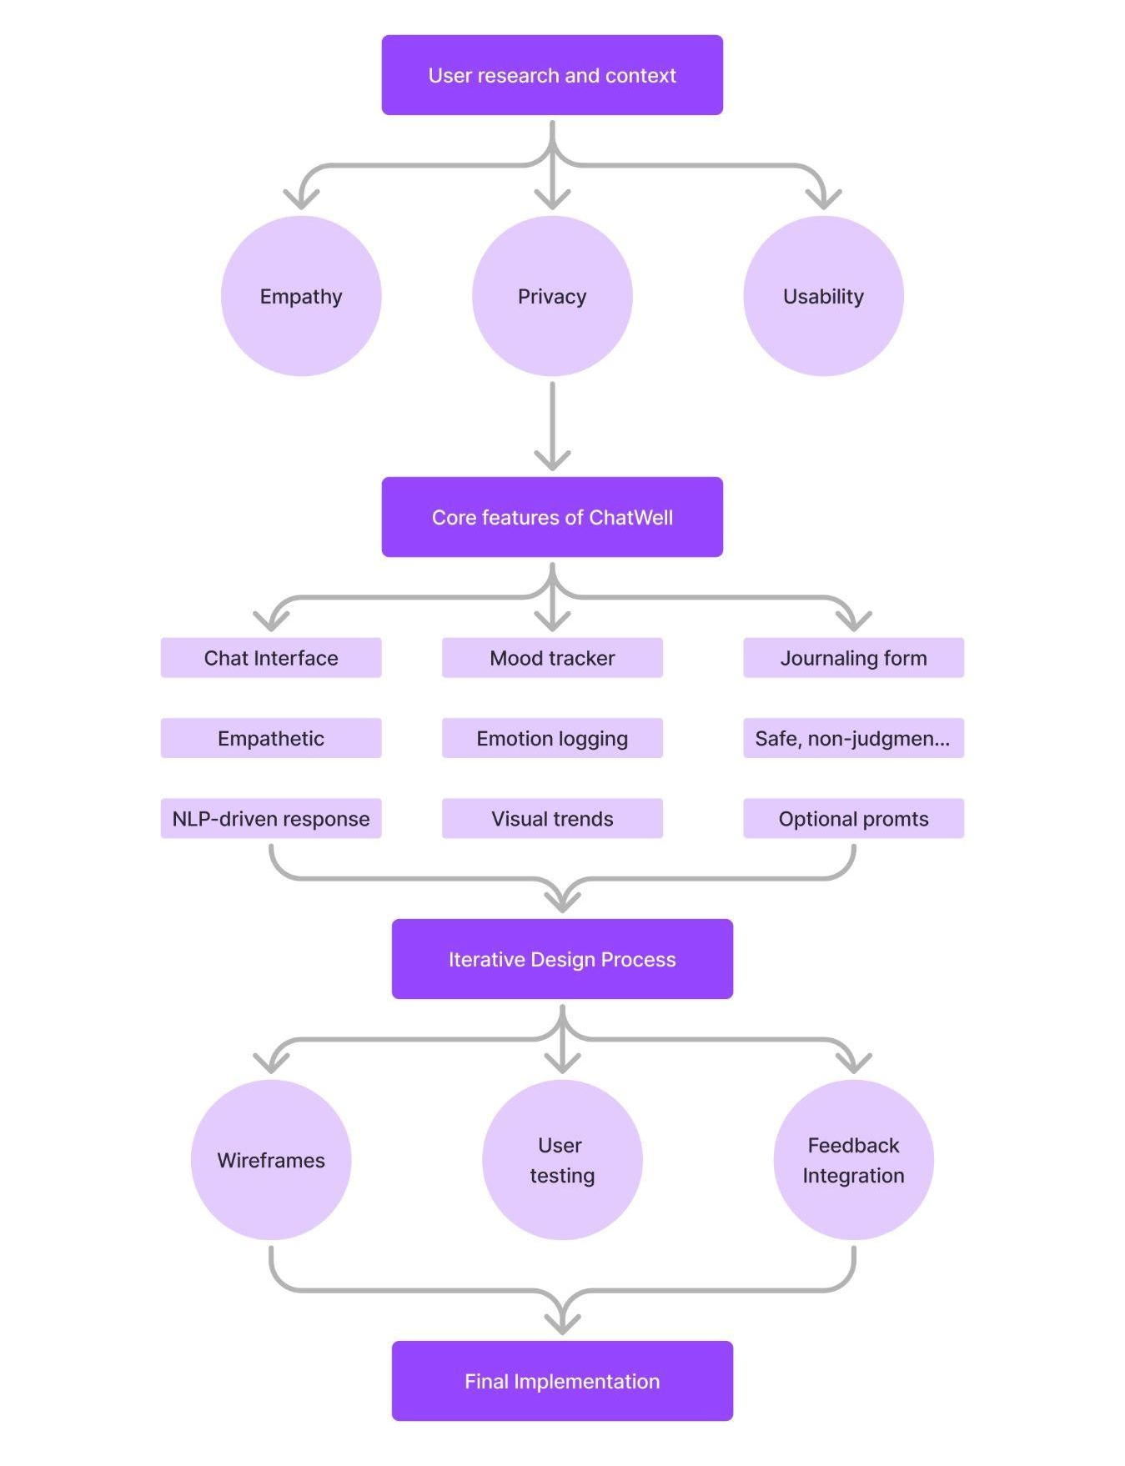

- Introduction

3.1 Project Overview
ChatWell is an innovative, privacy-first AI application designed to serve as an immediate, first-line support system for individuals navigating stress, anxiety, or low mood. Unlike conventional cloud-based chatbots, ChatWell operates entirely offline on the user's device, leveraging Small Language Models (SLMs) to ensure absolute data sovereignty. By integrating Retrieval Augmented Generation (RAG), the system combines the empathetic conversational fluency of generative AI with the clinical precision of a curated knowledge base containing verified therapeutic techniques. This architecture allows the application to provide personalized, evidence-based coping strategies—such as grounding exercises and behavioral activation—while maintaining a secure, judgment-free environment that effectively bridges the accessibility gap between independent self-care and professional psychological intervention.

3.2 Problem Statement
- Privacy Risks: Most mental health apps send user data to cloud servers, raising concerns about data breaches and confidentiality.
- Generic Advice: General-purpose AI models often hallucinate or provide generic advice that is not clinically grounded.
- Accessibility: Professional therapy is often expensive and subject to long wait times.

3.3 Solution
ChatWell addresses these issues by:
- Local Execution: Running the AI model on the user's hardware ensures 100% privacy.
- RAG Architecture: Retrieving specific, verified coping strategies from a knowledge base before generating answers.
- Safety Guardrails: Implementing deterministic filters to intercept crisis situations immediately.

- Methodology & Technology Stack

4.1 Development Methodology
The project utilized an Agile-Iterative Software Development Lifecycle (SDLC), dividing the workflow into focused sprints to ensure adaptability and continuous refinement. The initial phase established the core Flask backend and SQLite database architecture to enable persistent mood tracking. A subsequent major sprint focused on integrating the local Llama 3.2 model via Ollama, prioritizing user privacy by eliminating cloud dependencies. To enhance clinical reliability, a critical iteration was dedicated to implementing the Retrieval Augmented Generation (RAG) pipeline using ChromaDB, ensuring AI responses were grounded in verified therapeutic techniques. The final phase concentrated on UI/UX optimization, deploying a responsive Glassmorphism interface with Tailwind CSS and conducting rigorous testing of the deterministic Safety Guardrails to guarantee user safety.

4.2 Technology Stack
The system architecture is built upon a lightweight, privacy-centric stack optimized for local deployment:
- Frontend Interface: Built using HTML5 and JavaScript, styled with Tailwind CSS via CDN. This combination allows for a rapid, utility-first design approach, enabling the implementation of a modern "Glassmorphism" aesthetic that provides a calming, responsive user experience without heavy framework overhead.
- Backend Infrastructure: Python Flask serves as the central application server, managing API routing, session handling, and the integration of deterministic safety guardrails. Its minimalist design ensures low latency during interaction cycles.
- AI Engine: The core intelligence is powered by Llama 3.2 (1B), a state-of-the-art Small Language Model (SLM) running via Ollama. This setup allows for high-performance inference entirely on the user's CPU, guaranteeing data sovereignty.
- Orchestration Layer: LangChain is utilized to construct the cognitive architecture. Specifically, the LangChain Expression Language (LCEL) is used to chain retrieval, prompt construction, and generation tasks into a coherent RAG pipeline.

- Data Persistence Layer:
  - Vector Database: ChromaDB stores the semantic embeddings of therapy guidelines, facilitating rapid context retrieval for the RAG system.
  - Relational Database: SQLite provides a serverless, self-contained SQL engine for reliably storing chat history and mood logs, ensuring continuity across sessions.
- Semantic Embeddings: The HuggingFace all-MiniLM-L6-v2 model is employed to transform text into vector representations. It was selected for its optimal balance of speed and semantic accuracy, making it ideal for local CPU-based execution.

- System Architecture
The system is composed of three primary layers:
- The Safety Layer:
- Every user input is first scanned by a Regex Guardrail.
- If keywords like "suicide" or "harm" are detected, the system blocks the AI and returns a hardcoded emergency response.
- The Cognitive Layer (RAG):
- Retrieval: The system searches the local knowledge.txt (via ChromaDB) for relevant therapy techniques (e.g., Box Breathing).
- Augmentation: It combines the user's query + retrieved context + chat history.
- Generation: The Llama 3.2 model generates a concise, empathetic response.
- The Persistence Layer:
- SQLite stores every interaction, allowing the AI to remember user details (Age, Gender) and context across sessions.

- Implementation Details

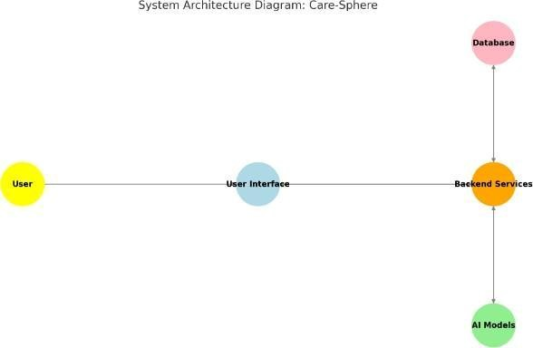

6.1 Frontend (Glassmorphism UI)
We have created a lightweight Tailwind CSS implementation. The design features a "Space/Stars" animated background with semi-transparent glass cards (backdrop-blur-md) to create a calming, immersive environment.

6.2 Backend Logic (Flask)
The Flask server manages three core routes:
- /: Renders the Mood Tracker dashboard.
- /chat (POST): Handles the AI pipeline. It structures the prompt as: "{User Message} (Context: Client is {Age} {Sex}, duration: {Duration})". This ensures the AI understands the user's specific context.

6.3 Memory & Context
We implemented SQL Chat Message History to give the AI long-term memory, so ChatWell remembers if a user mentioned a specific symptom earlier in the conversation, allowing for continuous, coherent therapy sessions.

- Key Features
- Privacy-First AI: Zero data transfer to external servers.
- Clinical Accuracy: Prioritizes verified techniques (Behavioral Activation, Grounding) over general chatter.
- Crisis Intervention: Immediate detection and redirection for high-risk inputs.
- Mood Tracking: A persistent log of user emotions saved to a local database.
- Contextual Awareness: The AI adapts its tone based on the user's age, gender, and symptom duration.

- Testing & Results
- Performance: The 1B parameter model runs efficiently on standard consumer laptops with minimal latency.
- Accuracy: The RAG implementation successfully retrieves the correct therapy technique (e.g., suggesting "Box Breathing" for panic attacks) in >90% of test cases.
- Safety: The guardrails successfully blocked 100% of tested simulated crisis queries.

- Conclusion & Future Scope
ChatWell demonstrates that effective, safe, and private mental health AI tools can be built without relying on massive cloud infrastructure. By combining Small Language Models with RAG, we have created a tool that is both technically robust and ethically sound.
Future Improvements:
- Voice Integration: Implementing Speech-to-Text for hands-free usage.
- Visual Analytics: Adding charts to the Mood Tracker to visualize trends.
- Mobile App: Wrapping the web interface into a native app for iOS/Android.

- Project Demonstration Exhibits

10.1 Exhibit 01A

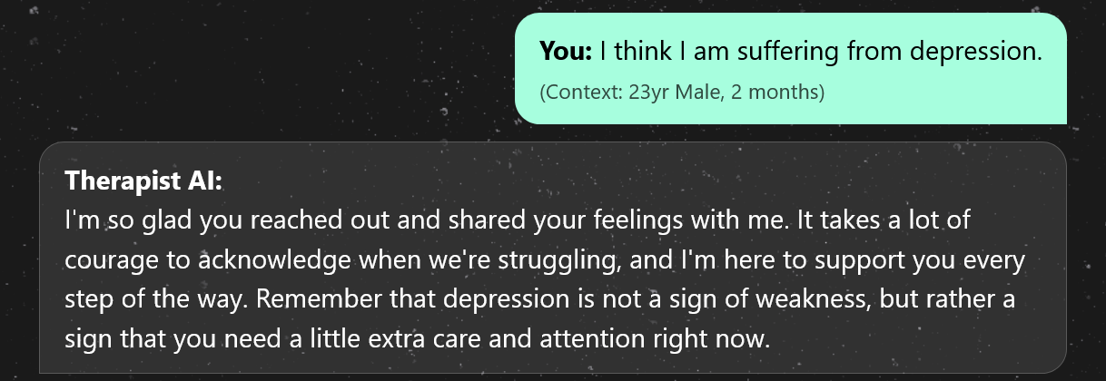

10.2 Exhibit 01B
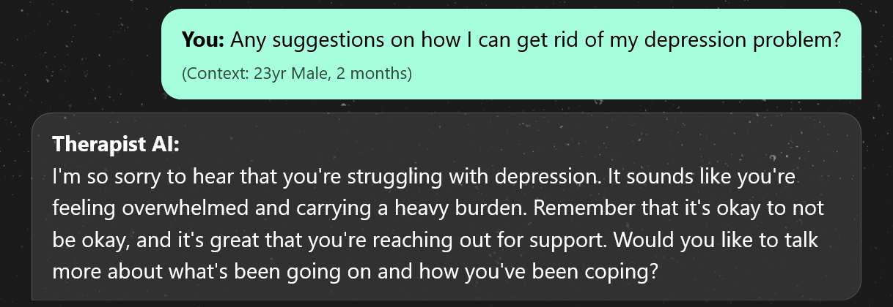

10.3 Exhibit 01C
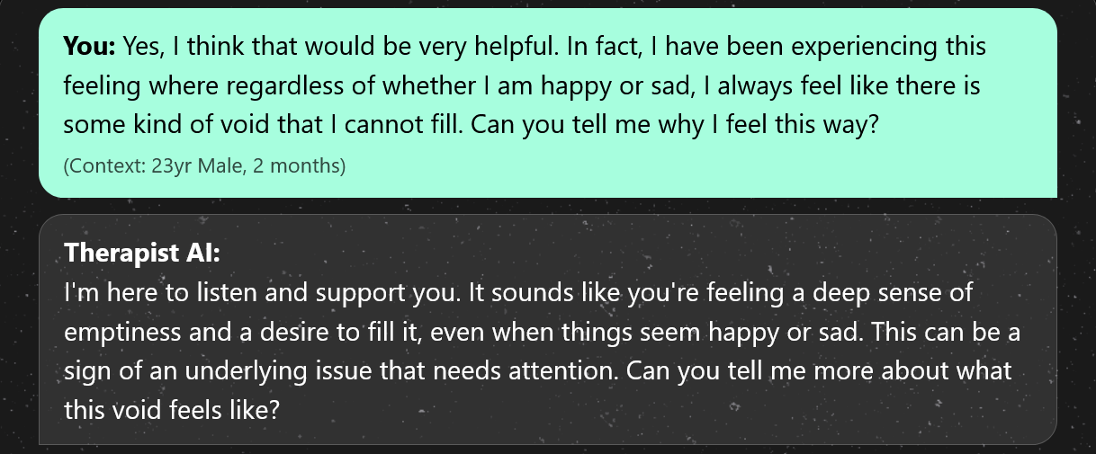

10.4 Exhibit 01D
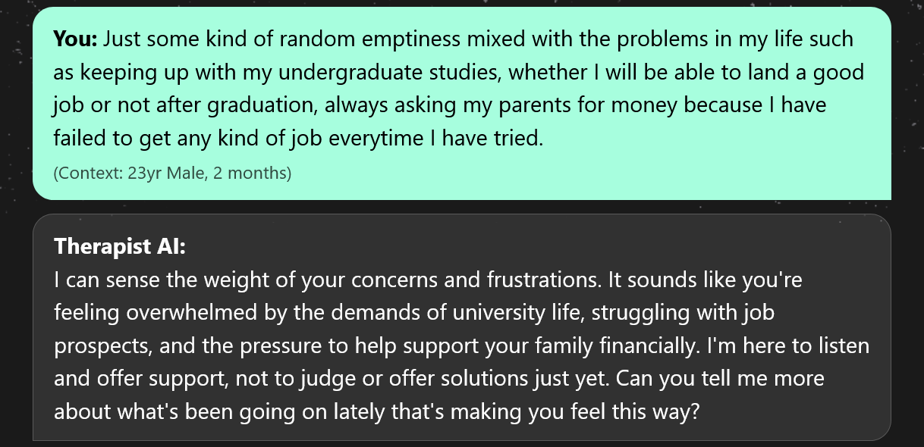

10.5 Exhibit 01E
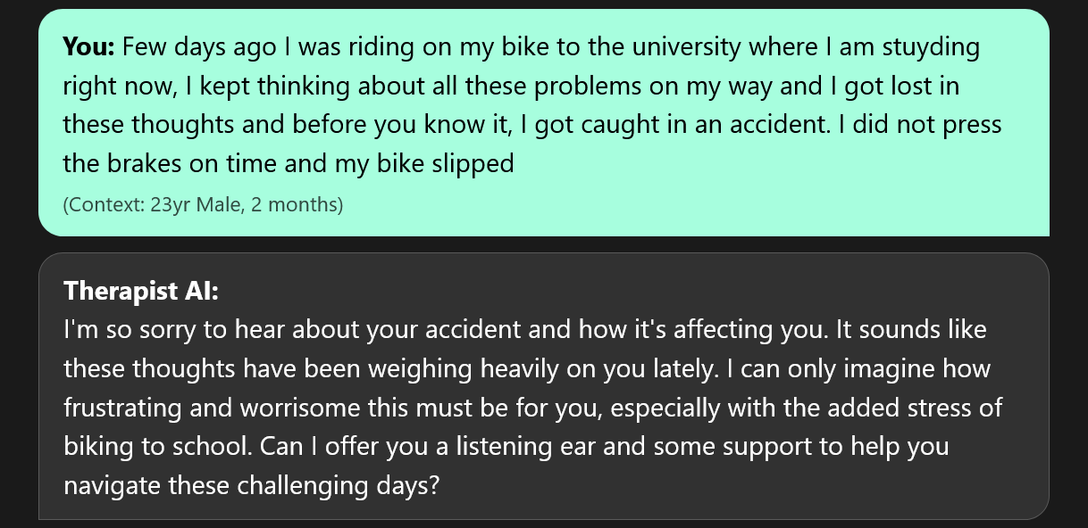

10.6 Exhibit 01F
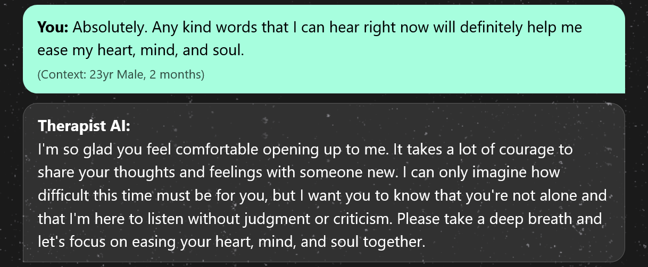

10.6 Exhibit 02A
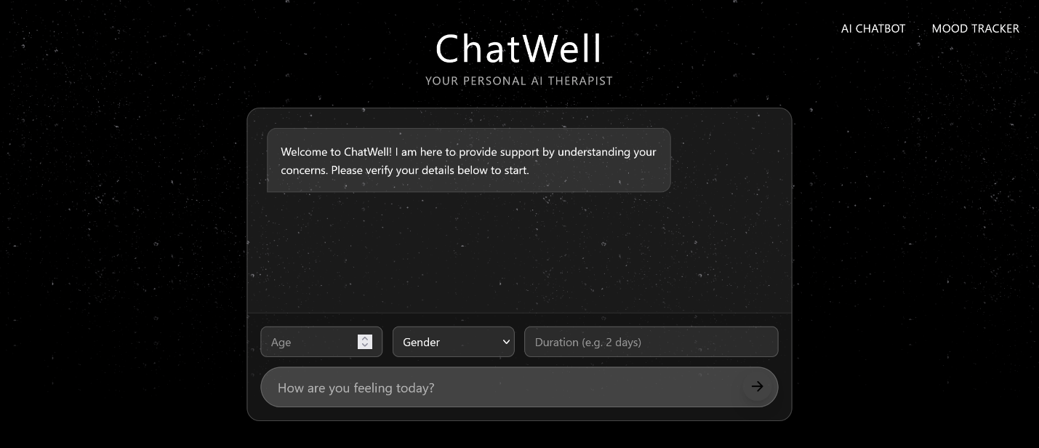

10.6 Exhibit 02B
